**PART 1. Questions (Total Marks: 8)**

1. Please identify the level of measurement of FacilityAim, StrorageLevel, DamType, and easting_m in the .csv dataset you exported. (4 marks)

**Answer:**

1. **FacilityAim**:

* **Level of Measurement:** Nominal (Qualitative)
* **Explanation**: FacilityAim categorizes the primary aim or purpose of each facility using non-numeric labels (e.g., "fa2", "fa7"). These categories do not imply any order or quantitative scale.

1. **StorageLevel**:

* **Level of Measurement:** Ratio (Quantitative)
* **Explanation**: StorageLevel measures the storage level of reservoirs in meters. It is a numerical value representing quantities with a meaningful zero point and measurable differences.

1. **DamType**:

* **Level of Measurement**: Nominal (Qualitative)
* **Explanation**: DamType categorizes the types of dams using non-numeric labels (e.g., "dt1", "dt5", "dt7"). Each type is distinct without any implied order or numerical value.

1. **easting_m**:

* **Level of Measurement**: Ratio (Quantitative)
* **Explanation**: easting_m measures the easting coordinate of dam locations in meters. It is a numerical value representing quantities with a meaningful zero point and measurable differences.

1. Which of the following variables are qualitative data? Multiple options are possible. (1 mark)

A. DamType B. FacilityAim C. DamHeight D. Northing_m E. StorageLevel.

**ANSWER**

The variables that are qualitative data from the given options are:

A. DamType

B. FacilityAim

1. Please classify the Dam Height (m) into 5 categories according to quantile classification. Recallthat quantile classes contain an equal number of features. Round your final answers whole numbers. (3 marks)

**ANSWER:**

To classify the Dam Height variable into 5 categories based on quantile classification, rounded to whole numbers, the following categories were determined:

1. **Short**: Dams with heights in the lower quantile range.
2. **Medium**: Dams with heights in the second quantile range.
3. **Moderate**: Dams with heights in the third quantile range.
4. **Tall**: Dams with heights in the fourth quantile range.
5. **Very Tall**: Dams with heights in the uppermost quantile range.

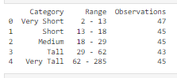

**PART 2. Questions (Total Marks: 12)**

1. What classification method and number of classes did you use? Justify your choice. Is the classification method used in question 3 for Dam Height (m) appropriate? Why?

**ANSWER**:

I used the Natural Breaks (Jenks) method with five classes for classifying `ImpoundmentLevel [mamsl]`. This method effectively identifies natural groupings within the data by minimizing variance within each class and maximizing variance between classes, which is ideal for the typically skewed distributions in environmental data. Five classes provide a balance between sufficient detail and simplicity, making it easier to interpret and visualize distinct patterns in impoundment levels.

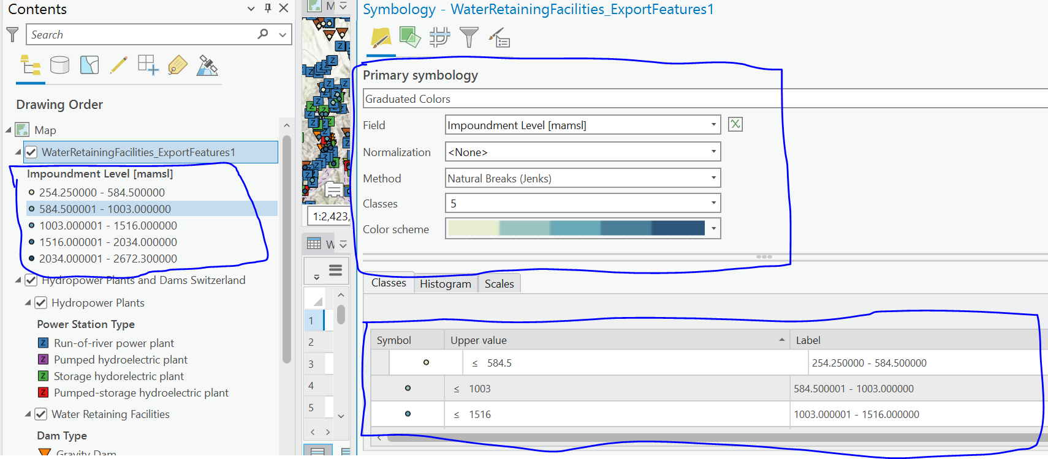

For question 3, the quantile classification method was used for Dam Height (m). Quantile classification is appropriate for ensuring an equal number of features in each class, which is useful for comparing relative positions across classes. However, it may not be as effective as Natural Breaks for highlighting inherent data patterns, especially if the data distribution is not uniform. Quantile classification can obscure significant natural groupings by forcing equal-sized classes, potentially leading to less meaningful categorizations in skewed datasets.

1. Examine your classified map “Impoundment Level” and describe the spatial pattern of your dataset (use location names and the hillshade to discuss features). What are some advantages ofspatial data compare to non-spatial data? (6 marks)

**ANSWER**

Upon analyzing the classified map of "Impoundment Level" with the hillshade layer in ArcGIS Pro, distinct spatial patterns emerge. The map clearly shows variations in elevation levels of water retention facilities across Switzerland.

**Spatial Pattern Description:**

* **Low Impoundment Levels:** Facilities with impoundment levels ranging from 254.25 to 584.5 meters are generally found in the lower elevation regions. These areas are often valleys and plains, like the Aarberg dam. The hillshade layer confirms these low-lying areas with gentler slopes and less rugged terrain.
* **Medium Impoundment Levels:** Dams with impoundment levels between 584.51 and 1003 meters are located in mid-elevation zones. These regions are typically found along the foothills, showing a gradual increase in elevation. The hillshade highlights moderate slopes and a mix of flat and hilly areas.
* **High Impoundment Levels:** Dams with impoundment levels between 1003.1 and 1516 meters are situated in higher altitude regions. These facilities are positioned in more mountainous terrain, which is evident from the hillshade depicting steeper slopes and rugged landscapes. Examples include the Airolo and Albbruck-Dogern dams.
* **Very High Impoundment Levels:** Facilities with impoundment levels between 1516.1 and 2034 meters and above are found in the alpine regions. The Albigna and Alp Dado dams, located at very high elevations, align with the steep, rugged terrain seen in the hillshade.

**The Figures Below shows a glimpse of visuals.**

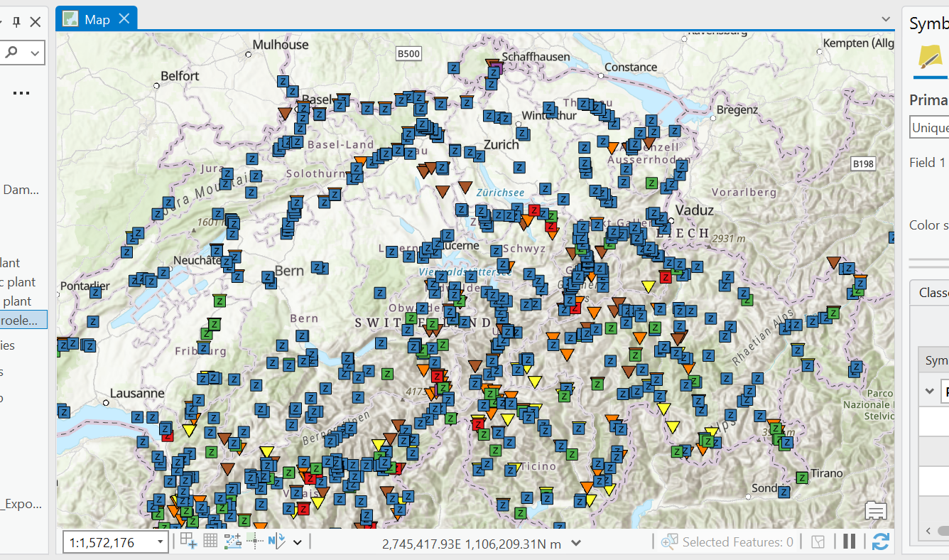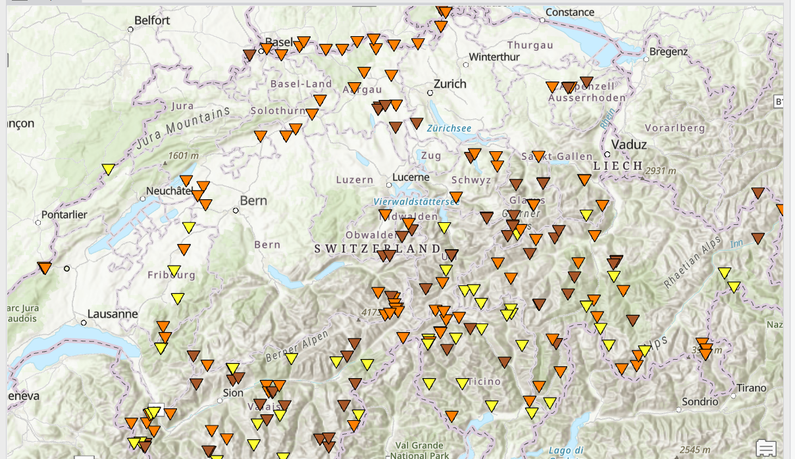

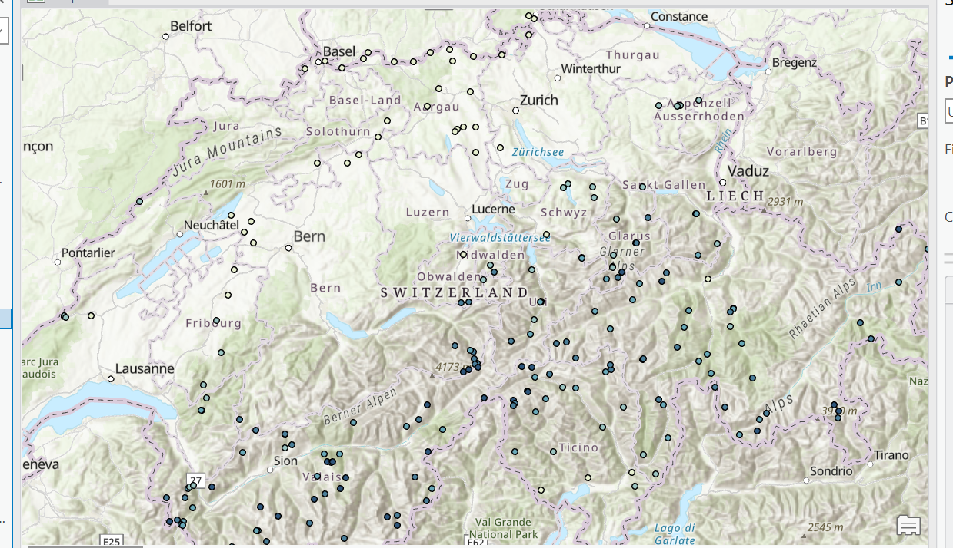

**Advantages of Spatial Data Compared to Non-Spatial Data:**

1. **Visualization:** Spatial data allows for the creation of maps that provide a visual understanding of geographic patterns and distributions. This visualization helps to quickly grasp complex data relationships.
2. **Contextual Analysis:** Spatial data links information to specific locations, providing context for understanding how geographic features influence the dataset. This is critical for identifying regional trends and patterns.
3. **Spatial Relationships:** Spatial data facilitates the analysis of relationships such as proximity, clustering, and dispersion, which are not discernible from non-spatial data. For example, identifying clusters of dams at certain elevation levels.
4. **Decision Making:** Spatial data supports better decision-making by providing geographic context, which is essential in fields like urban planning, environmental management, and infrastructure development.

**PART 3. Questions (Total Marks: 12)**

All answers of part 3 are done in Rstudio and are present in attached file Assignment.html

Attached files:

* Assignment.html (markdown of R scripts)
* Assignment.RMD (actuall R Scripts)